COPPER HILL PROJECT: INTEGRATION OF TRADITIONAL GEOLOGY AND NEW TECHNOLOGIES TO BUILD A DEPOSIT MODEL
Stuart Hayward ⁽¹⁾, Glenn Coianiz ⁽²⁾, Bret Ferris ⁽³⁾, Greg Corbett ⁽⁴⁾
- 360 Geoscience Pty Ltd/ CMC Geos, PO Box 779 Kenmore QLD 4069 AUSTRALIA
- ExplorIS Pty Ltd, PO Box 5257 Lismore East NSW 2480 AUSTRALIA
- Golden Cross Resources Ltd, 22 Edgeworth David Ave Hornsby NSW 2077 AUSTRALIA
- Corbett Menzies Cunliffe, PO Box 282, Willoughby, NSW, 2068
Key Words: geology model, copper, gold, Copper Hill, Buckleys Hill, porphyry copper, epithermal, Lachlan Fold Belt, Molong, Orange, oriented drill core, deposit model, Lachlan Orogen, Leapfrog, radial basis function, isosurface, mineral resource estimation, JORC

Abstract
Copper Hill is a porphyry copper-gold mineralised system (Corbett and Leach, 1998) hosted within and genetically related to diorite porphyry and multiphase calc-alkaline tonalite porphyry intrusions of the Copper Hill intrusive complex (CHIC), emplaced into basaltic-andesitic to andesitic lava, dacitic volcanics, volcaniclastic conglomerate and breccia of the Fairbridge Volcanics. Copper-gold mineralisation, emplaced throughout the evolution of the intrusive complex, and associated alteration have been placed within a paragenetic sequence using field relationships in orientated drill core and outcrop. A proposed sequence of up to 9 pre-, syn- and post-mineralisation intrusion events is separated by periods of uplift and erosion and changes in orientation of principal structural stresses, which may have acted as triggers or intrusion emplacement and mineralisation (Corbett and Leach, 1998; Corbett, 2014).
Six stages of mineralisation are proposed, each with distinct with vein style, alteration and mineralisation characteristics. Early Stage 1-2 low-grade copper mineralisation (0.1-0.3% Cu, 0.1-0.3 g/t Au) occurs as disseminated chalcopyrite and sparse porphyry style A, B, and D veins within and contiguous with intrusions and structures with northwest trends. High grade Stage 3 copper-gold mineralisation (0.3-5.4% Cu, 0.1-18.4 g/t Au) is associated with steep dipping sheeted and stockwork quartz+magnetite+sulphide A, B, M, and C porphyry style vein arrays within structures and peripheral to microtonalite porphyry intrusions. In Stage 4, carbonate base metal veins and shears are telescoped on top of earlier mineralisation. Shut down of the hydrothermal system is signalled by Stage 5 gypsum+laumontite veins in structures and fracture zones. The final Stage 6 is characterised by the development of a leached cap and sub horizontal zone of supergene copper.
The geological model developed from the 2014 drilling program utilised a combination of sectional 2D interpretation and isotropic and anisotropic 3D implicit grade shell isosurface modelling at multiple copper cut-off grades using the Leapfrog® Radial Basis Function (RBF) process. The derived isosurfaces which contain a geological foundation serve as templates for construction of estimation domains that were utilised dependent on geostatistical exploratory data analysis.
The use of tighter geological controls for the mineral resource model facilitated the development of a combined mineral resource estimate of 28Mt @ 0.56% Cu and 0.53g/t Au at 0.4% Cu cut-off grade for 160,000t Cu (1% increase) and 480,000 ounces Au (9% increase). (Ridley, 2015; GCR, 2015).

Introduction
Copper Hill is reputed to be the first copper mine in New South Wales with copper production recorded from 1845-1931. Exploration for copper and later copper-gold has been carried out since 1966 to present day. Golden Cross Resources Limited (GCR) has explored Copper Hill since 1998 with a view to moving the project from exploration through to feasibility and ultimately production. Geological data has been collected, stored, and managed over time to varying standards and degrees of rigor with interpretations taking a sectional 2D approach. GCR set out in April 2014 to establish a consolidated 3D geological model of Copper Hill with high quality reliable data sets from six new drill holes across the deposit, and reconnaissance surface mapping. The approach taken by the project geology team was to combine traditional back-to-basics geology data collection and analysis, smartphone digital data capture tools and, more recently available computer modelling tools, to verify and validate geology data and models compiled throughout the project’s history. The outcome is a series of 3D scenarios with strong geological support for an updated mineral resource estimate.
Surface mapping and structure models compiled by Chivas in 1971 and enhanced by Cyprus Amax in later years has been ratified utilising smartphone applications combined with historical drill hole and GIS data sets. Orientated drill core measurements of structures, veins and contacts combined in 3D space support the predominant trends mapped at surface and provide a basis for the geological model. Significant structural trends that control the distribution and geometry of each phase of deposit evolution have been identified as early northwest trending structures and intrusions broadly parallel to the regionally significant Lachlan Transverse Zone, east-west dilatant structures which host sheeted vein sets and intrusions associated with high-grade zones, and less dominant north-south trending vein sets and structures.
Historical geological models were constructed by combining sectional 2D interpretations in order to create a 3D model for target generation and mineral resource estimation. The low angles between structures and drill sections made interpretation difficult. The geological model developed from the 2014 drilling program utilised a combination of sectional 2D interpretation and construction of isotropic and anisotropic 3D implicit grade shell isosurface models at multiple copper cut-off grades using the Leapfrog® Radial Basis Function (RBF) process. 3D surfaces of major structures and sheeted vein trends condition the anisotropic RBF calculations and result in previously enigmatic and disparate mineralised intercepts becoming a logical and better fit with the structural architecture and mineralisation styles of the deposit. The derived isosurfaces which contain a geological foundation serve as templates for construction of estimation domains that were utilised dependent on geostatistical exploratory data analysis.

Geological Setting
Copper Hill is located within the Lachlan Orogen (Glen, 2006) of eastern Australia, a 1,000 kilometre wide complex Early Cambrian to Early Carboniferous orogenic belt that developed along the paleo-Pacific margin of the Australian craton during the Palaeozoic (Foster et al., 1999; Hoy, 2007). The Lachlan Orogen contains Early Ordovician to Early Silurian, volcano-intrusive complexes known as the Macquarie Arc (Mowatt & Smith, 2006) and include four broadly north-south trending Ordovician age belts (Junee – Narromine Volcanic Belt (JNVB); Molong Volcanic Belt (MVB); the Rockley – Gulgong Volcanic Belt (RGVB); and, in the south, the Kiandra Volcanic Belt (KVB)). Copper Hill is situated on the western margin of the central part of the Molong Volcanic Belt (Figure 8).
The mineralised system is hosted within, and is genetically related to, early diorite porphyry and later multiphase calc-alkaline tonalite porphyry intrusions of the Copper Hill intrusive complex (CHIC). Tonalite porphyry intrusions form stocks, dykes and intrusion breccias within wall rock basaltic-andesitic to andesitic lava, dacitic volcanics, volcaniclastic conglomerate and breccia of the Fairbridge Volcanics, a member of the Ordovician Cabonne Group (Figure 9). Silurian to Early Devonian volcanic and sedimentary rocks of the Cowra-Yass and Hill End troughs surround the Molong Volcanic Belt.
A sequence of up to 9 pre-, syn- and post-mineralisation intrusion events is proposed based on observations of primary texture, cross cutting field relationships, and vein/mineralisation styles associated with each intrusion. Primary textures alone cannot define the relationship between tonalite porphyry intrusions and mineralisation as intrusions with similar primary textures are observed throughout the history of mineralisation.
Quartz diorite porphyry (QDP) crops out as an east-west elongate body southeast of the main tonalite porphyry bodies. The outcrop distribution, occurrence as xenoliths within later tonalite porphyry intrusions, and lack of extensive fracturing and hydrothermal alteration, place this unit as the earliest intrusion phase of the CHIC. This QDP is green-grey massive, equigranular and comprises 1-2 mm tabular plagioclase phenocrysts (40%), dark green interstitial hornblende up to 3 mm (20%), quartz (10-15%), minor magnetite and chlorite derived from the alteration of biotite (Hoy, 2007).

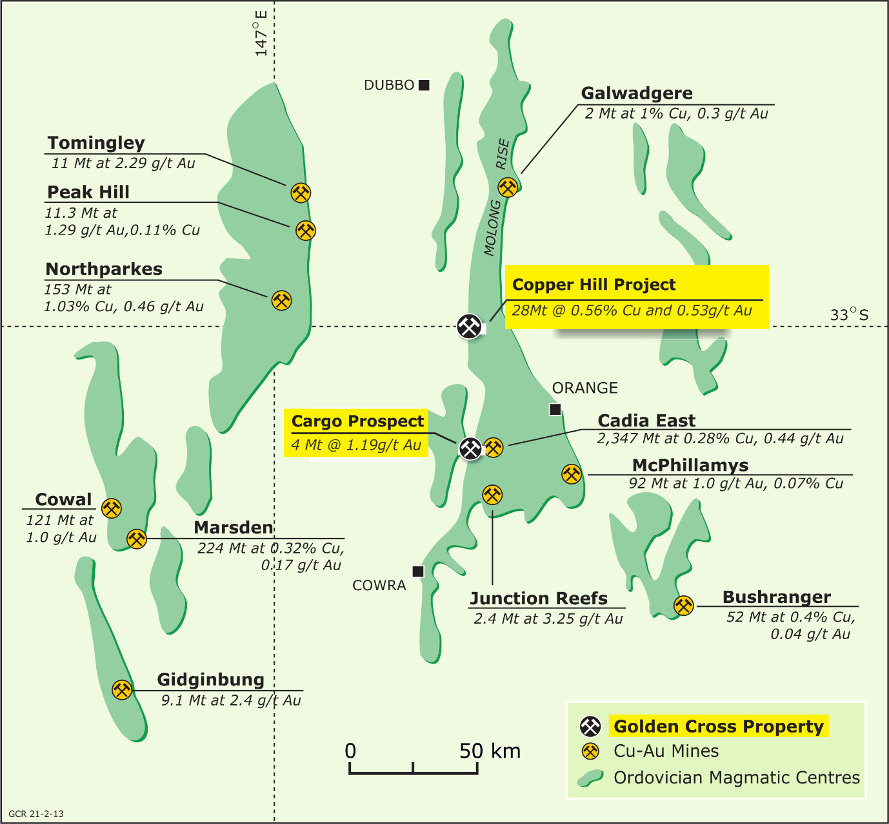

Figure 8. Schematic map of the Macquarie Arc, eastern Lachlan Orogen showing main Ordovician belts and major deposits in central New South Wales (GCR, 2015).

Multiple phases of pre- and syn-mineralisation crowded tonalite porphyry (CTP) and microtonalite porphyry (MTP) form the main northwest trending stocks of the CHIC. Crowded tonalite porphyry is characterised by crowded, seriate textures with minor quartz and hornblende phenocrysts, and xenoliths of QDP and MTP. Chivas and Nutter (1975), Scott (1978), Blevin and Morrison (1997), Hoy (2007) and Corbett (2006, 2013, 2014) recognised two main phases of CTP based on primary textural features of grain size and quartz content. The northeastern portion of the main intrusive body comprises a coarse-grained (3-5mm) CTP with sparse plagioclase megacrysts and occasional quartz eyes. On the southwest side, the CTP displays a finer grained (1-2mm) seriate texture with 1-3% quartz eyes. The eastern contact zone with the Fairbridge Volcanics contains intrusion breccia textures with the proportion of intrusive matrix increasing towards the centre of the complex (Figure 13, Figure 14).
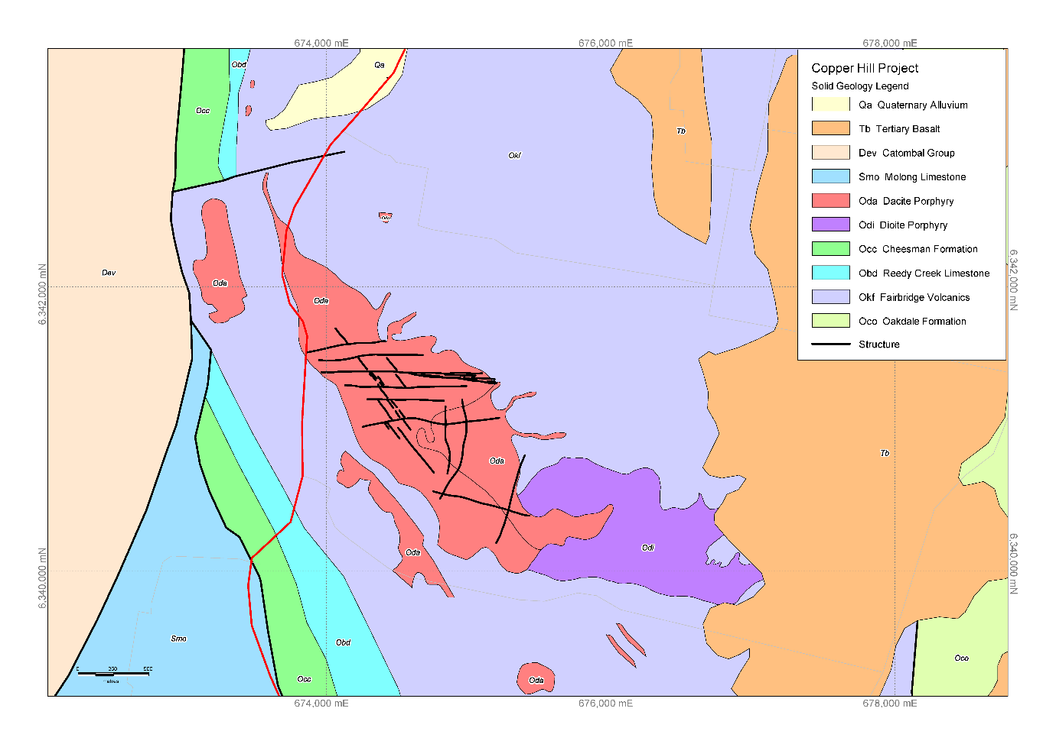Figure 9. Copper Hill solid geology interpretation with major structural trends derived from surface mapping and orientated drill core measurements. (Geology by Hayward and Coianiz; Adapted from Bathurst 1:250000 geology sheet and Chivas 1971 ).

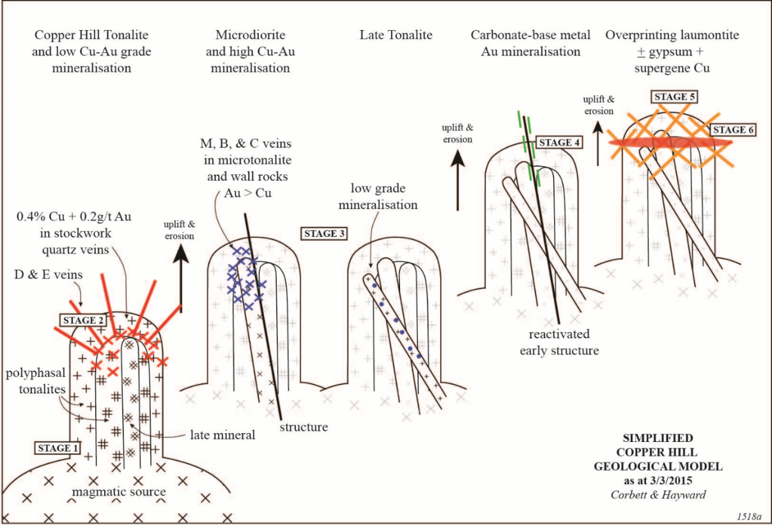
Figure 10. Copper Hill simplified conceptual geological model showing overprinting stages, but with earlier events not drawn on the later stages (Corbett & Hayward, March 2015).
Syn- and post-mineralisation CTP in GCHD470 are texturally similar to the main body and characterised by cross-cutting field relationships and different mineralisation style associated with each phase.
Microtonalite porphyry (MTP) intrusions represent a suite of fine to medium-grained plagioclase-phyric stocks and dykes with minor (<1%) subhedral quartz phenocrysts and occasional CTP xenoliths. Microtonalite porphyry is usually strongly altered and temporally and spatially associated with high grade copper-gold mineralisation as sheeted and stockwork porphyry-style veins and disseminated sulphides, along east-west trending structures, and at the intersections of major structures. MTP are volumetric small with dykes to 10m thick in the new drill hole GCHD474 and a 75 metre down-hole thickness in DDH GCHD470. The vertical extent of the MTP is not fully defined by drilling.
Quartz tonalite porphyry (QTP) is the predominant post-mineralisation intrusion phase. QTP breccia clasts with quartz veins in GCHD469 at Buckleys Hill suggest QTP intrusions were also been present within the early intrusion history or the deposit or the breccias were driven by a later intrusion event. QTP is a coarse-grained (3-5mm), massive porphyry with variable (3-7%) subhedral to bipyramidal quartz phenocrysts and red orange hematite dusting. The largest QTP body occurs on the western margin of Buckleys Hill with all drill holes terminating in this unit.
Late stage unaltered barren dykes of hornblende tonalite porphyry (HTP), sparse feldspar tonalite porphyry (SPTP), andesite dykes and brown dacite porphyry cross-cut the volcanic stratigraphy and all earlier porphyry intrusions.
Hydrothermal breccias (HBX) occur throughout the intrusion and mineralisation history of Copper Hill. HBX at Buckleys Hill closest to the QTP contact contain quartz vein and K-feldspar altered porphyry clasts sourced from depth (Figure 13). HBX outboard further to the east are similar to quartz-magnetite vein clast dominant syn- to post main stage mineralisation HBX below the former open pit.

Mineralisation and Alteration
Copper Hill is classified as copper-gold porphyry mineralisation (Corbett and Leach, 1998) that is spatially and temporally associated with variably mineralised calc-alkaline tonalite porphyry intrusions and as wallrock porphyry mineralisation in Fairbridge Volcanics and early stage intrusions. Six stages of mineralisation are proposed that span the porphyry and epithermal environment (Figure 3; Corbett and Hayward, unpubl.data) consistent with a typical porphyry-epithermal transition, (Figure 11, Corbett, 2014). The staged evolution of porphyry copper-gold systems (Figure 12) described by Corbett (2009, 2014) provides a basis for interpretation of spatial and timing relationships of intrusion phases in the development of the Copper Hill system, and the inference of tectonic events such as uplift and erosion and rotation of directions of principal stress regime throughout the evolution of the magmatic hydrothermal system, illustrated in Figure 10.
Copper and copper-gold mineralisation has been emplaced repeatedly throughout the evolution of the Copper Hill system with the spatial distribution and geometry of each event of mineralisation and associated prograde and retrograde hydrothermal alteration being highly variable over short distance.
Stage 1- Stage 1 copper mineralisation is characterised by low grade (0.1-0.2% Cu) copper as dominantly disseminated and micro fracture controlled chalcopyrite that is localised close to the contact between of the early crowded tonalite porphyry and quartz diorite porphyry (Chivas 1971, Hoy 2007), and within the broader pre-mineralisation crowded tonalite porphyry intrusions. Fine grained biotite-magnetite hornfels and quartz-calcite-chlorite-magnetite-pyrite+chalcopyrite+molybdenum distal E-veins within Fairbridge Volcanics above and peripheral to Buckleys Hill to the northeast of the main intrusion system is interpreted to have been driven by the hydrothermal system associated with the earliest phases of Stage 1 quartz diorite and crowded tonalite porphyry intrusions.
Stage 1 mineralised zones reflect the northwest trending geometry and distribution of the early tonalite porphyry intrusions, forms the bulk of mineralisation at Copper Hill and represents a background to all subsequent stages of mineralisation.
Stage 2- Copper+molybdenum mineralisation (0.2-0.4% Cu, 0.2 g/t Au, 100ppm Mo) characteristic of the mid to upper levels of a porphyry system and peripheral to the porphyry source occurs in northwest trending structures with strong quartz-sericite-pyrite alteration + disseminated and vein style chalcopyrite+molybdenum [D-veins to quartz-sulphide veins] on the western side of Copper Hill. While the wall rocks to Stage 2 mineralisation comprise early crowded tonalite porphyry and Fairbridge Volcanics, no source porphyry has yet been recognised in drill core.
Sericite-dominant hydrothermal alteration mapped at Copper Hill is interpreted to have formed as part of stage 2 and is broadly zoned around the core of the system and mineralised structures. Peripheral albite-sericite-pyrite (ACS) alteration occurs at depth and on the eastern margins of the system, peripheral to widespread sericite-chlorite-carbonate (SCC) alteration and is characterised by the complete alteration of feldspar and mafic minerals (Hoy 2007). Chlorite aggregates (spots) are characteristic of SCC alteration and signal passing out of the core of the system. Structurally controlled quartz-sericite-pyrite (QSP) alteration with leached textures and weak disseminated chalcopyrite-molybdenum overprints all earlier assemblages. Broad zones of weak argillic alteration developed as part of the QSP extend to depth and along structures on the western margins of the complex.
Stage 3- Stage 3 is the main high-grade copper-gold event (0.4-5.3%Cu, 0.4-18.9g/t Au) at Copper Hill inclusive of low grade intra-mineral intrusions as the magmatic system wanes. Mineralisation is characterised by quartz-magnetite M-veins, quartz-sulphide B-veins, and cross-cutting chalcopyrite+bornite C-veins as sheeted vein sets and lesser stockwork vein arrays, spatially and temporally associated with fine grained microtonalite porphyry dykes and stocks. Chalcopyrite within the M veins was introduced by the C veins after the original laminated quartz-magnetite. Wispy magnetite fractures in sericite-chlorite-magnetite (SCM) signal lateral and vertical proximity to mineralised structures passing inwards to A-B and M style porphyry veins akin to potassic alteration, with some earlier or later sericite. Surface mapping shows significant lateral continuity (400-600m) of east-west trending sheeted vein sets and dykes emplaced along these structures. Stock-like microtonalite and associated stockwork veins intruded at the intersection of the east-west and northwest trending structures display a more localised distribution (100-200m).
Potassic alteration is inferred from quartz-magnetite veins, secondary biotite (now altered to retrograde chlorite) vein selvages and actinolite. Pervasive K-feldspar was not recognised, with the exception of altered clasts within hydrothermal breccia at Buckleys Hill.
Highest gold-copper grades are associated with the late C-vein event which cuts the M and B veins, a common feature of porphyry systems. Gold-copper ratios are zoned, with 1:1 on the periphery and 2:1 and 3:1 central to structures and mineralised intrusions (Figure 14, Figure 15), as the bornite within M veins provides a preferential host for Au. C-veins show a strong east west preferred orientation in all the recent drill holes and is discernible in the open pit consistent with the structural model proposed (Corbett and Leach, 1998) to account for most Central West mineralisation, which suggests the northwest to east-west orientation of many vein systems reflects development within dilatant sites formed by sinistral movement on the north-south structural fabric of the district. In this model the east-west veins will be better mineralised.
Stage 3 mineralisation is less extensive than combined Stage 1 and Stage 2, challenging the historical view that the Copper Hill mineralised system potential has been downgraded by later barren intrusion events.
Stage 4- The geological evolution of the Copper Hill mineralised system was impacted by a second event of uplift and erosion telescoping carbonate-base metal gold (CBM) style veins (in the classification of Corbett and Leach, 1998) with sericite-carbonate selvages on top of all earlier mineralisation. The carbonate species (calcite, Mn-Mg carbonate + rhodochrosite) and abundance of low temperature Fe-poor white and lesser yellow sphalerite support a distal setting for this mineralisation above the source porphyry. The orientation of Stage 4 veins is predominantly east-northeast implying preferential dilation on existing structures caused by a small component of dextral reversal of movement on regional scale bounding structures at this stage. Transient changes in the nature of convergence to sinistral orthogonal on the NS structural grain may have acted as a trigger for mineralisation.
Retrograde sericite-chlorite-carbonate alteration associated with shut-down of the hydrothermal system overprints earlier stages.
Stage 5- Gypsum veins often in association with laumontite (zeolite) fracture fill are recognised throughout the prospect as late stage structurally controlled vein zones on the flanks of the intrusion-hydrothermal system. Stage 5 is unmineralised and interpreted as the near neutral shut-down of the hydrothermal system where available sulphur is preferentially precipitated as sulphate minerals.
Stage 6- The upper portions of the Copper Hill system have undergone strong weathering and leaching to a depth of approximately 30-70m below surface. Pervasive sericite-chlorite-carbonate-pyrite alteration weathers to produce acid ground waters that leach and strip the rock mass of copper-gold mineralisation, redepositing it in a contiguous sub-horizontal zone at the base of oxidation, commonly termed the chalcocite blanket in other porphyry systems. The leached cap is generally barren of copper mineralisation except for the open pit area.

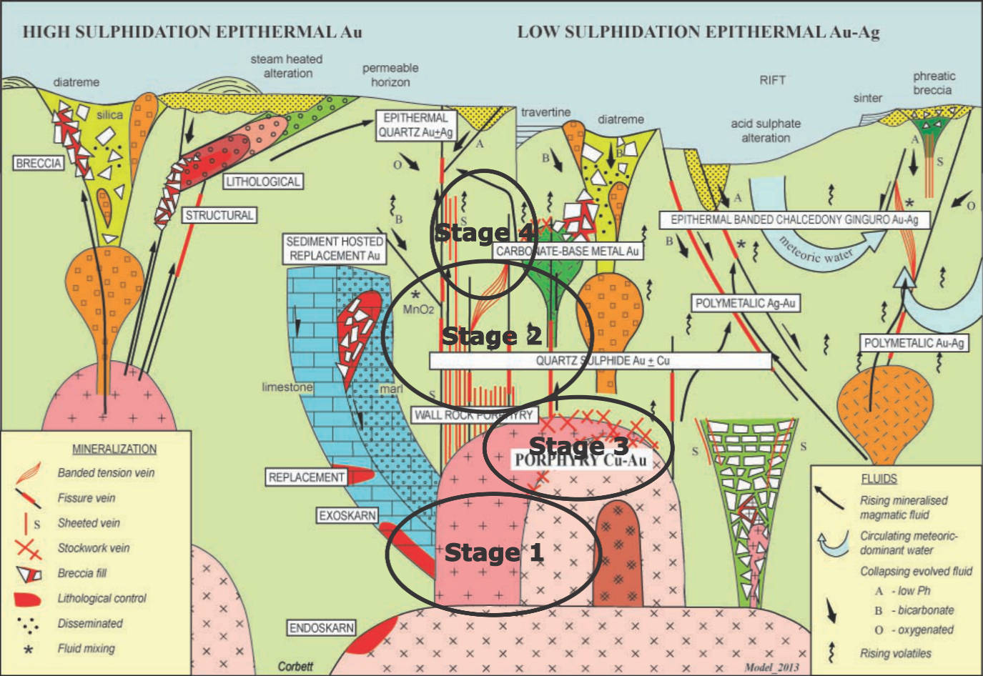

Figure 11. Mineralised systems in the porphyry and epithermal environment (Corbett 2014) and interpreted key stages in the evolution of the Copper Hill mineralised system.

Structure
Porphyry systems develop within convergent subduction related tectonic regimes in both continental and island arc settings. Deep seated arc parallel and regional scale arc-normal transfer structures are key to providing a framework for the plumbing and emplacement of magma bodies at with changes in the nature of convergence which act as triggers to emplacement of intrusions at higher levels and formation of porphyry and porphyry related mineralised systems (Corbett and Leach, 1998). CHIC has developed at the intersection of major north-south trending arc parallel structures on the western margin of the Molong Ordovician belt, and regional northwest trending transfer structures. A component of sinistral strike slip movement on the arc parallel structures provided dilation on the existing northwest transfer structures for emplacement of the diorite and tonalite porphyry intrusions (Corbett 2013a, b).
The structural regime active at the time of intrusion of the CHIC was characterised by regular changes the principal stress regime to promote sinistral strike-slip movement on the north-south structures and dilation on pre-existing northwest to east-west structures throughout the deposit evolution. Primary stress regime is inferred to have been predominantly horizontal in order to generate steep dipping intrusion geometry, mineralised sheeted vein arrays and structures. The shallow (10-15⁰) westerly dip of layering within the Fairbridge Volcanics at Buckleys Hill suggests there has been only minimal tilting of the local stratigraphy.
Geological and structural mapping has been carried out by tenement holders over the life of the Copper Hill project. Work completed by Chivas in 1971, and reproduced and enhanced throughout the project history is the most widely used surface solid geology map (Figure 9). A recent review of the surface geological interpretation showed a move away from structures that align with the Chivas (1971)/Cyprus (1990) map and created uncertainty in relation to the actual structure architecture to be used as a foundation for 3D geological and development of the resource model.

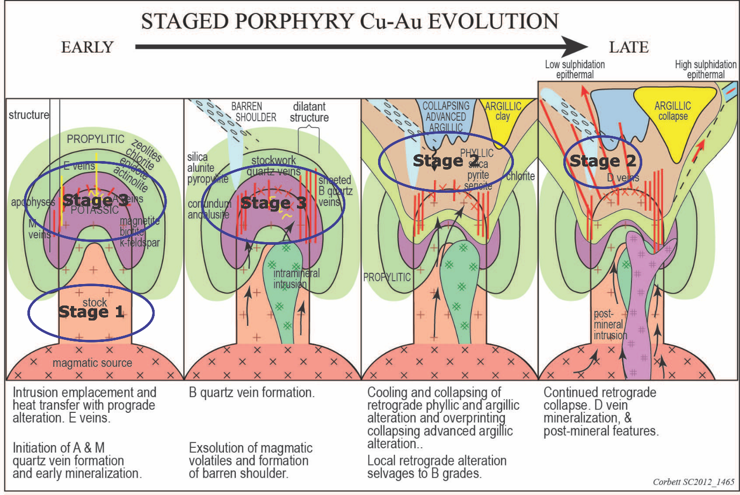

Figure 12. Staged porphyry Cu-Au evolution (Corbett 2013) and interpreted key stages in the evolution of the Copper Hill mineralised system.

Reconnaissance mapping of structures in outcrop was carried out as part of the 2014 drill program to evaluate the validity of recent versus historical surface structure models. A baseline survey in the open pit area using standard tape and Brunton compass survey when compared against smartphone application Fieldmove Clino® measurements of structures were within several degrees of each other and well within the limits of operator variability. When plotted in GIS, Fieldmove Clino® measured structures are located close to the on-ground position displayed by the orthorectified aerial photography image.
Combined surface mapping and 10,764 oriented drill core measurements reinforces the dominant east-west, northwest, and north-south structural architecture mapped at surface. Mineralised vein orientations describe a stockwork with a dominant sheeted vein orientation that is not uncommon in porphyry systems (Figure 17). Steep (67⁰ – 70⁰) north dipping, east-west trending Stage 3 mineralised structures are dominant and subordinate northwest Stage 1 and Stage 2 structures. Subsets of data by easting, northing, level, and by prospect reflect this pattern with slight changes in dominant strike and stress regime at that time.
Post-mineralisation fault activity is inferred to have taken place in association with uplift and erosion and telescoping successive stages of alteration and mineralisation. Two major late-stage structural trends are interpreted. When viewed in long section a major east-west trending ‘break’ is inferred between Copper Hill and Buckleys Hill with >500m north-block-down movement juxtaposing deep level porphyry mineralisation against higher level porphyry system indicators at Buckleys Hill. A ductile fault system interpreted along the western margin of Copper Hill is characterised by zones of intense shearing which passes laterally into zones of gypsum and/or laumontite fracture/vein development as late reactivation and sealing of the structures.

3D Geological Model
The previous geological model combined sectional 2D interpretations to create a 3D model for target generation and mineral resource estimation. The low intersection angles between mineralised sheeted veins and intrusions, and the drill sections made interpretation difficult.
The geology model and paragenetic sequence derived from traditional approaches has four fundamentals that:
- the copper and copper-gold mineralisation paragenesis, and structural and mineralogical controls have been determined and are robust;
- early Stage 1 lower grade mineralisation lies predominantly in the moderately dilatant northwest trending structures;
- high-grade Stage 3 mineralisation is controlled by the more dilatant predominantly east-west trending structures;
- there is supergene Cu and probably Au enrichment in the oxidised upper portions to form sub-horizontal higher grade zones.
Therefore the primary underlying assumption for 3D computer based geology model is that isosurfaces at specific copper cut-off grades reflect the low and high grade mineralisation stages (0.1% Cu, 0.3% Cu, 0.6% Cu), when conditioned by 3D surfaces for structures and key geological features will reasonably reflect the three dimensional nature of the deposit.
The geology model for the 2014 drilling program utilised a combination of sectional 2D interpretation and implicit modelling of isotropic (spherical) and anisotropic 3D grade shell isosurfaces at multiple copper cut-off grades in the Leapfrog® Radial Basis Function (RBF) process.
Isotropic isosurfaces with equidistant spherical search parameters and no structural conditioning highlights the underlying regional northwest orientation of the low grade system (Figure 18a).
3D surfaces of major structures and sheeted vein trends condition the anisotropic RBF calculations resulting in retention of the regional northwest trend at low grades, and strong regional east-west trend of higher grades (>0.3% Cu) (Figure 18b). Anisotropic modelling allows previously enigmatic and disparate mineralised intercepts to become logical and better fitting with the structural architecture and mineralisation styles of the deposit.
The derived anisotropic isosurfaces with a geological foundation serve as templates for construction of estimation domains that are utilised dependent on geostatistical exploratory data analysis (EDA).

Figure 13. Geological interpretation at Buckleys Hill on cross section 6150mN (Hayward, 2014)

Mineral Resource
A clear understanding of the geology of a project and the geological controls on mineralisation facilitated the provision of a robust and defensible geological model as the foundation for the development of a mineral resource estimation. The combination of traditional and modern geological approaches with a 3D computer-based model along with appropriate check and verification steps, has achieved an updated geology based mineral resource for Copper Hill. Tighter geological controls on the estimation of domain geometry and parameter determination reflect the geological controls to mineralisation and have therefore facilitated an improved outcome for the project.

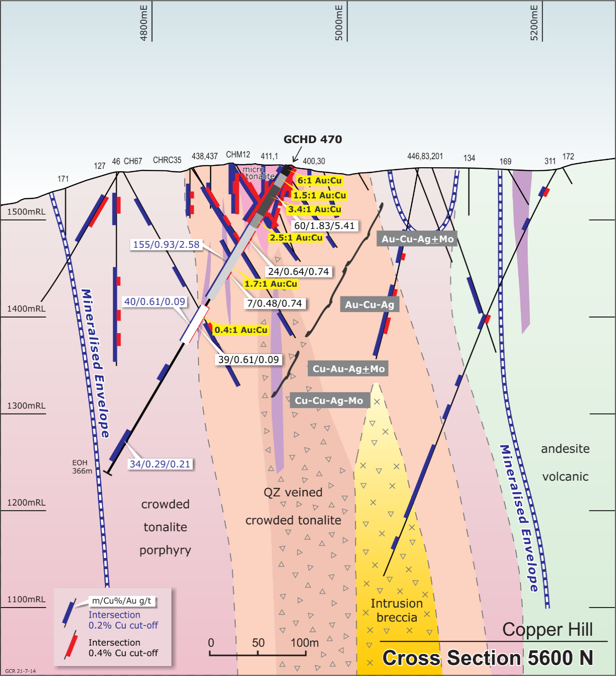

Figure 14. Zoned mineralisation patterns around drill hole GCHD470 (Hayward 2014). High-grade mineralisation can be considered as gold-copper. The oxide zone within the open pit has the highest Au:Cu ratio at 6:1.

The 2015 mineral resource estimate resulted in combined inferred and indicated material totalling 28Mt @ 0.56% Cu and 0.53g/t Au for 160,000t Cu (1% increase) and 480,000 ounces Au (9% increase) at 0.4% Cu cut-off grade. A net increase in metal content within the high grade (>0.4% Cu) resource and a reduction in tonnes of lower grade (<0.4% Cu) mineralisation. (Ridley 2015; GCR, 2015).

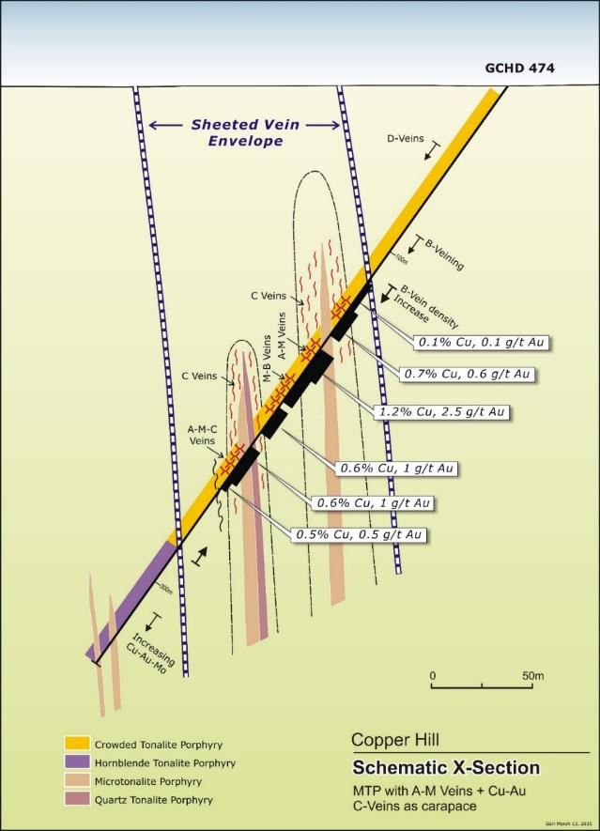

Figure 15. Schematic cross section of drill hole GCHD474 (Hayward, 2015). Narrow microtonalite porphyry dykes with associated A- M- & B-Veins and high copper-gold grades associated with later C-vein (chalcopyrite+bornite) event. Veins form carapace-like features attenuated along strike and to a lesser extent up dip.

Conclusions
There are many prospects and projects that have been explored over the decades that may not have been, or continue to be considered unprospective for economic mineralisation based on ‘reputation’. Integration of traditional and modern data collection approaches to surface and drill hole data, utilisation of modern computer based analysis and processing tools, combined with traditional geology approaches and models for mineralised systems, demonstrates that a robust geology based deposit model of Copper Hill is achievable. The key factor is the link between good fundamental geological observations, and an analysis by geologists which allowed logical and rational verification of computer generated models and scenarios.
Recognition that the high-grade copper-gold event at Copper Hill can be genetically and spatially defined, and potentially not downgraded by later intrusion events, has facilitated the generation of extension and expansion exploration targets.
Continued drill tests might now be oriented to better intersect the mineralised veins at higher angles to the core axis.
The use of a robust 3D geology model for mineral resource modelling has resulted in a mineral resource estimate that meets JORC 2012 guidelines. Combined inferred and indicated mineral resources at 0.4% Cu cut-off grade are 28Mt @ 0.56% Cu and 0.53g/t Au for 160,000t Cu (1% increase) and 480,000 ounces Au (9% increase). (Ridley, 2015; GCR, 2015).

Acknowledgements
The authors would like to thank Golden Cross for permission to publish this paper. Special thanks go to the site support personnel of Brendan Roberts and Mick Bates for their patience laying out and restacking voluminous amounts of drill core for review.

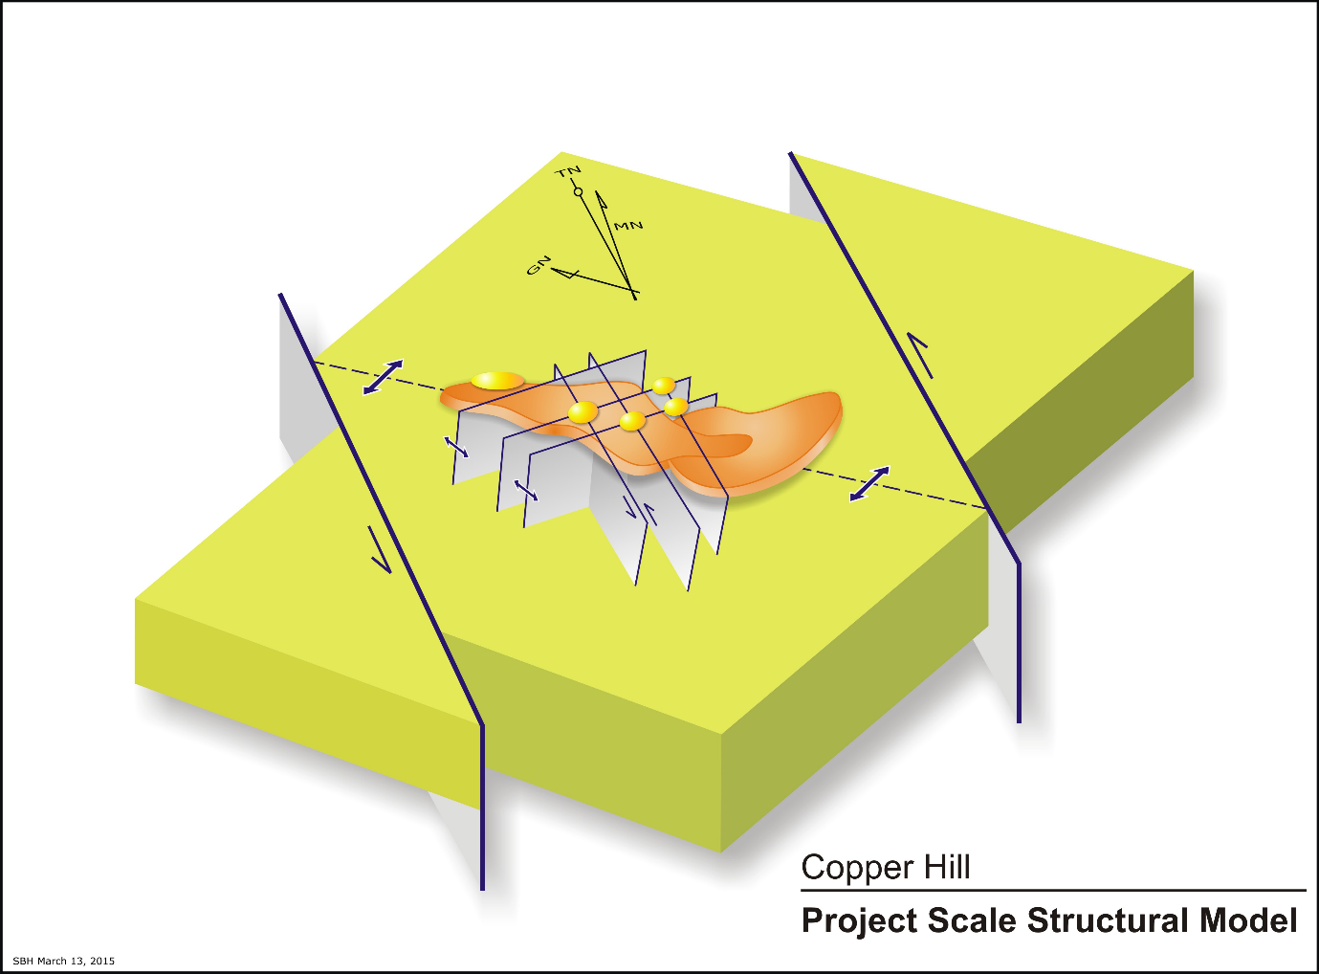Figure 16. Local structural architecture of the Copper Hill mineralised system (Hayward, 2015).

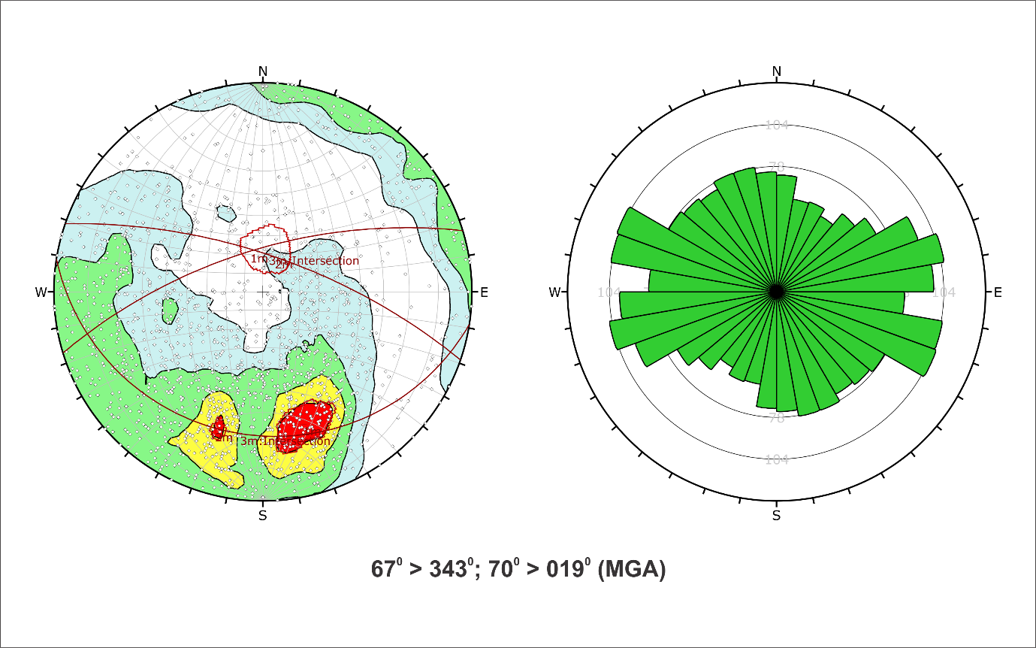

Figure 17. Copper Hill orientated drill core data (1795 poles to planes) for all mineralised veins. East-West trending vein sets are dominant over North-South and Northwest trends (Coianiz 2014, Coianiz 2015).

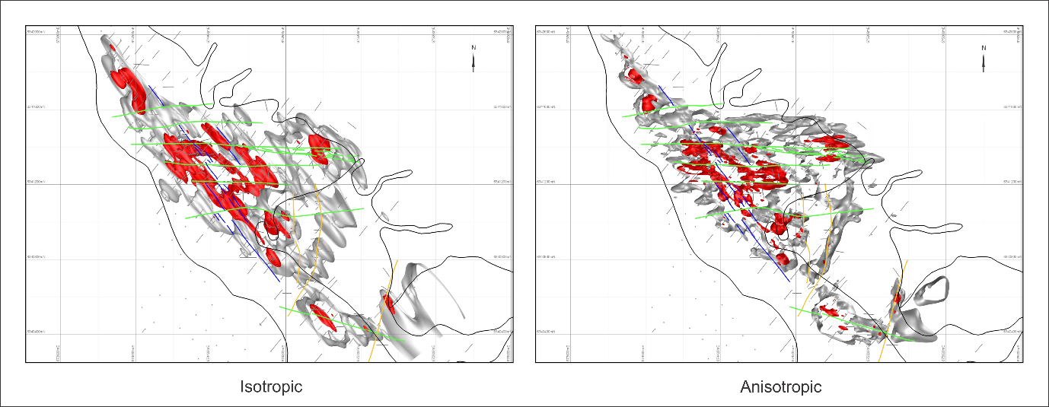
(a)
(b)

Figure 18. Level Plan at 1500mRL on Copper Hill local grid (a) Isotropic isosurfaces at 0.1% Cu (grey) & 0.3%Cu (red), (b) Anisotropic isosurfaces at 0.1%Cu (grey) & 0.3% Cu (red). [Blue lines = Regional NW trending structures; Green = E-W trending dilational structures; Yellow = Regional N-S trending structures] (Hayward and Coianiz, 2015)

References
Blevin, P. and Morrison, G. 1997. Magmatic and Hydrothermal Evolution of Major Intrusive Related Gold Deposits, AMIRA Final Report p 425 (unpublished).
Chivas, A.R. 1971, The Geology of Copper Hill near Molong, NSW. BSc (Hons) Thesis, University of Sydney (unpublished).
Chivas A.R., and Nutter A.H. 1975, Copper Hill Porphyry-Copper Prospect in Knight, C.L. (Ed), Economic Geology of Australia and Papua New Guinea, I Metals: AustIMM Monograph 5 pp. 716-720.
Coianiz, G. 2014. Compilation of Orientated Structures from Drill Core at Copper Hill, New South Wales. Unpublished internal memorandum for Golden Cross Resources.
Coianiz, G. 2015. Review of Structural Trends from the Recorded Oriented Structures at Copper Hill. Unpublished internal memorandum for Golden Cross Resources.
Corbett, G.J. 2006, Comments on the geology arising from a brief inspection, or the Copper Hill Project, New South Wales, Australia: Unpublished report to Golden Cross Resources.
Corbett, G.J. 2013a, Comments arising from a brief inspection of the Copper Hill Project: Unpublished report to Heron Resources.
Corbett, G.J. 2013b, Tasmanides Arc-style Au-Cu Mineralisation, in a Pacific Rim Context. Mine and Wines 2013, AIG
Corbett, G.J. 2014, Epithermal and porphyry ore deposits: Field aspects for exploration geologists – Short course notes (unpublished).
Corbett, G.J. and Leach, T.M., 1998, Southwest Pacific gold-copper systems: Structure, alteration and mineralization: Special Publication 6, Society of Economic Geologists, 238
Foster, D.A., Gray, D.R., and Bucher, M. 1999. Chronology of deformation within the turbidite-dominated, Lachlan Orogen: Implications for the tectonic evolution of eastern Australia and Gondwana. Tectonics, 18, 452–485.
Golden Cross Resources, Quarterly Report December 2014. 14p.
Hoy, J.L. 2007, The geology, alteration, mineralization, and structure of the Copper Hill porphyry system, New South Wales. Unpublished Honours Thesis, University of Wollongong.
JORC, 2012. Australasian Code for Reporting of Exploration Results, Mineral Resources and Ore Reserves.
Mowat, B., and Smith, S. 2006. Characteristics of porphyry Au-Cu systems in the Ordovician Macquarie Arc of NSW. In Lewis.P.C. ed. Mineral Exploration Geoscience in New South Wales, Mines and Wines Conference, Cessnock, NSW.SMEDG, pp.11-17.
Percival, I.G., Glen, R.A. 2007, Ordovician to earliest Silurian history of the Macquarie Arc, Lachlan Orogen, New South Wales, Australian Journal of Earth Sciences, 23p.
Ridley, J.A. 2015, Report on Resource Estimation for Copper Hill Project, Consultant report by Ridley Mineral Resource Consulting Pty Ltd for Golden Cross Resources (unpublished)
Wilson, A.J. 2003. The geology, genesis and exploration context of the Cadia gold copper porphyry deposits, New South Wales, Australia. PhD. Thesis, University of Tasmania (unpublished).

